**IP Lab**

**Experiment - 9**

Name: Shashwat Tripathi

Class: D15A

Roll no: 64

Aim: To study the basics of Bootstrap.

Theory:

Introduction:

Bootstrap is an open-source front-end framework created by Twitter. It's designed to streamline the process of developing responsive and mobile-first websites and web applications. Bootstrap provides a collection of pre-designed HTML, CSS, and JavaScript components, allowing developers to create visually appealing and consistent user interfaces.

Key Features:

1. Responsive Design:

- Bootstrap adopts a mobile-first approach, ensuring that web pages look good and function well on various devices, from desktops to smartphones.

2. Grid System:

- The framework includes a responsive grid system, which is a flexible layout structure based on a 12-column design. This grid system simplifies the creation of complex layouts.

3. Components:

- Bootstrap offers a comprehensive set of UI components, such as buttons, forms, navigation bars, modals, carousels, and more. These components are customizable and provide a consistent design across different parts of a website.

4. Utilities:

- Bootstrap includes utility classes that help developers apply common styles and layout adjustments with minimal effort. These utility classes enhance code readability and maintainability.

5. Typography:

- The framework provides a consistent and visually appealing typography system, ensuring a harmonious presentation of text content across the application.

6. Themes and Skins:

- Bootstrap facilitates theming and skinning, allowing developers to customize the appearance of their projects. There are also third-party themes available, offering a wide range of design choices.

7. Browser Compatibility:

- Bootstrap is designed to be compatible with popular web browsers, ensuring a consistent user experience across different browser environments.

Community and Documentation:

1. Documentation:

- Bootstrap offers extensive and well-organized documentation, providing detailed information on each component, feature, and customization option.

2. Community Support:

- A vibrant and active community surrounds Bootstrap, providing support, sharing knowledge, and contributing to the ongoing development of the framework.

COde:

<!DOCTYPE html>

<html lang="en">

<head>

<meta charset="UTF-8">

<meta name="viewport" content="width=device-width, initial-scale=1, shrink-to-fit=no">

<title>Movie Ticket Booking</title>

<!-- Include Bootstrap CSS -->

<link rel="stylesheet" href="https://stackpath.bootstrapcdn.com/bootstrap/4.5.2/css/bootstrap.min.css">

<!-- Your custom styles can go here -->

<style>

/* Add your custom styles here */

</style>

</head>

<body>

<!-- Navigation Bar -->

<nav class="navbar navbar-expand-lg navbar-light bg-light color-[#3C0664]" style="background-color: #3C0664;">

<a class="navbar-brand" href="#">Movie Booking</a>

<button class="navbar-toggler" type="button" data-toggle="collapse" data-target="#navbarNav" aria-controls="navbarNav" aria-expanded="false" aria-label="Toggle navigation">

<span class="navbar-toggler-icon"></span>

</button>

<div class="collapse navbar-collapse" id="navbarNav">

<ul class="navbar-nav ml-auto">

<li class="nav-item active">

<a class="nav-link" href="#">Home <span class="sr-only">(current)</span></a>

</li>

<li class="nav-item">

<a class="nav-link" href="#">Movies</a>

</li>

<li class="nav-item">

<a class="nav-link" href="#">Cinemas</a>

</li>

<li class="nav-item">

<a class="nav-link" href="#">Offers</a>

</li>

<li class="nav-item">

<a class="nav-link" href="#">Sign In</a>

</li>

</ul>

</div>

</nav>

<!-- Hero Section with Carousel -->

<div id="carouselExample" class="carousel slide" data-ride="carousel">

<div class="carousel-inner">

<div class="carousel-item active">

<img src="avengers.jpg" class="d-block w-100" alt="Movie 1">

</div>

<div class="carousel-item">

<img src="avengers.jpg" class="d-block w-100" alt="Movie 2">

</div>

<div class="carousel-item">

<img src="afterlife.jpg" class="d-block w-100" alt="Movie 3">

</div>

</div>

</div>

<!-- Featured Movies Section -->

<div class="container mt-5">

<h2>Featured Movies</h2>

<div class="card-deck">

<div class="card">

<img src="download%20(2).jpg" class="card-img-top" alt="Movie 1">

<div class="card-body">

<h5 class="card-title">Movie 1</h5>

<p class="card-text">Brief description of Movie 1.</p>

</div>

</div>

<div class="card">

<img src="p7764_v_h8_am.jpg" class="card-img-top" alt="Movie 2">

<div class="card-body">

<h5 class="card-title">Movie 2</h5>

<p class="card-text">Brief description of Movie 2.</p>

</div>

</div>

<div class="card">

<img src="cars.jpg" class="card-img-top" alt="Movie 3">

<div class="card-body">

<h5 class="card-title">Movie 3</h5>

<p class="card-text">Brief description of Movie 3.</p>

</div>

</div>

</div>

</div>

<!-- Booking Widget -->

<div class="container mt-5">

<h2>Book Your Tickets</h2>

<form>

<!-- Your booking form goes here -->

</form>

</div>

<!-- Footer -->

<footer class="bg-light mt-5 py-3">

<div class="container">

<div class="row">

<div class="col-md-6">

<p>&copy; 2023 Movie Booking</p>

</div>

<div class="col-md-6 text-right">

<!-- Social media icons or links can go here -->

</div>

</div>

</div>

</footer>

<!-- Include Bootstrap JS and Popper.js -->

<script src="https://code.jquery.com/jquery-3.5.1.slim.min.js"></script>

<script src="https://cdn.jsdelivr.net/npm/@popperjs/core@2.9.1/dist/umd/popper.min.js"></script>

<script src="https://stackpath.bootstrapcdn.com/bootstrap/4.5.2/js/bootstrap.min.js"></script>

</body>

</html>

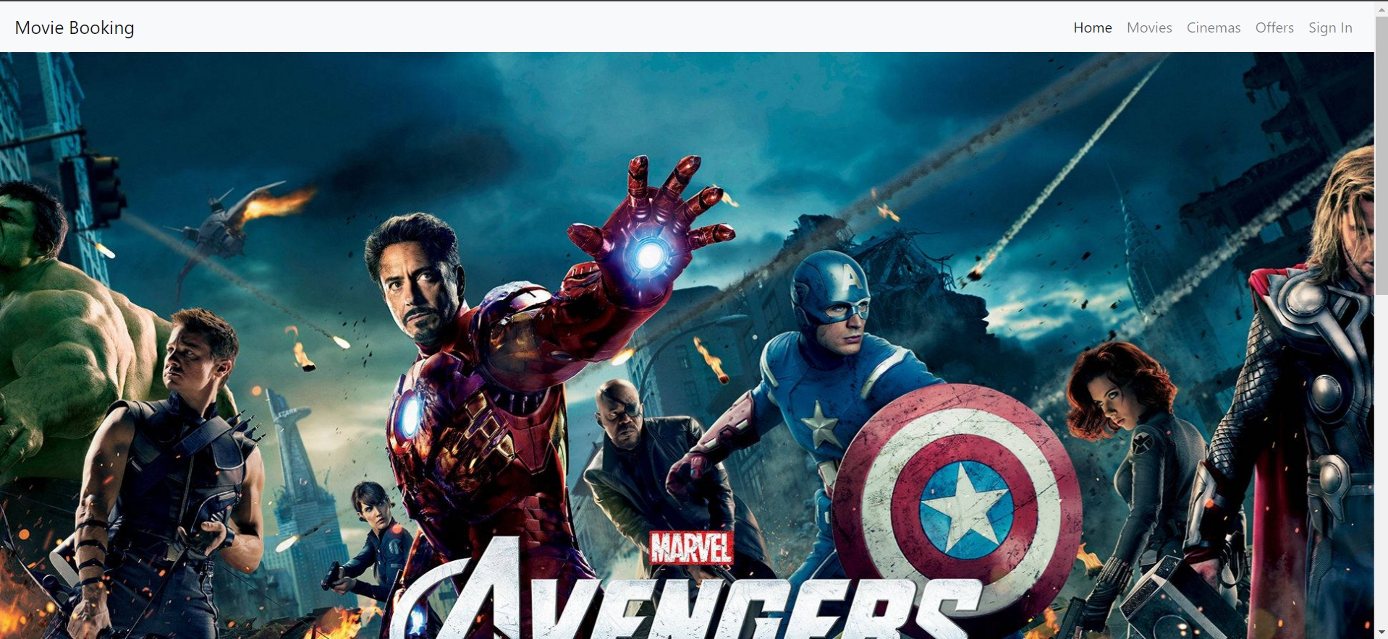

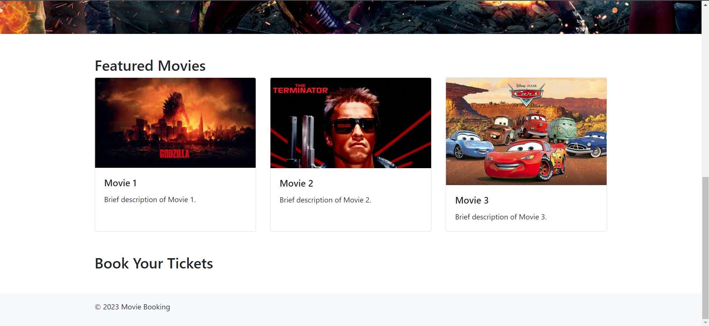

Responsive view

